November – Diaper Drive Month

Griffin Muffler & Brake Center of Fort Madison, IA is spearheading a Diaper Drive for the month of November for the families of Lee County in need of an adequate amount of diapers.

According to Community Action of Lee County, there are approximately 1200 children ranging from infants to toddlers in need of diapers. Community Action can only give 6 diapers at a time to families asking for help. There is a huge shortage.

The National Diaper Bank states there should be up to 12 diaper changes a day to keep the child healthy and promote development. That’s over 14,000 diapers a day in Lee County alone at an average cost of $80.00 per month for one child. The number of diapers for one year per child is 2457 according to DiaperPlanner.com. The break down is 0-3 Months up to 10 per day, 3-6 Months up to 7 per day and 6-11 Months up to 5 per day. These numbers are staggering.

Most working parents rely on child care. Most child care facilities require parents to provide diapers for their child. Without child care, parents can’t work or attend school. 72% of Iowa mothers are in the workforce. The national average is 63%. Fortunately, Early Head Start provides diapers for infants and toddlers.

DataUSA states there are over 16,000 workers in Lee County. 16.4% of Lee County families are below poverty rate. If 75% of the employees of Lee County would donate one package of diapers, that would total 12,000 packages of diapers.

Please help the families of Lee County with a need for diapers by donating a package today. Drop off areas are at Griffin Muffler & Brake Center 535 Ave G, all Connection Bank offices and MidWestOne Bank at 926 Ave G.

If you have any questions or ideas on how to make November Diaper Drive Month for Lee County, please call Nannette Griffin at 319-372-2478 or email griffinmuffler@gmail.com.

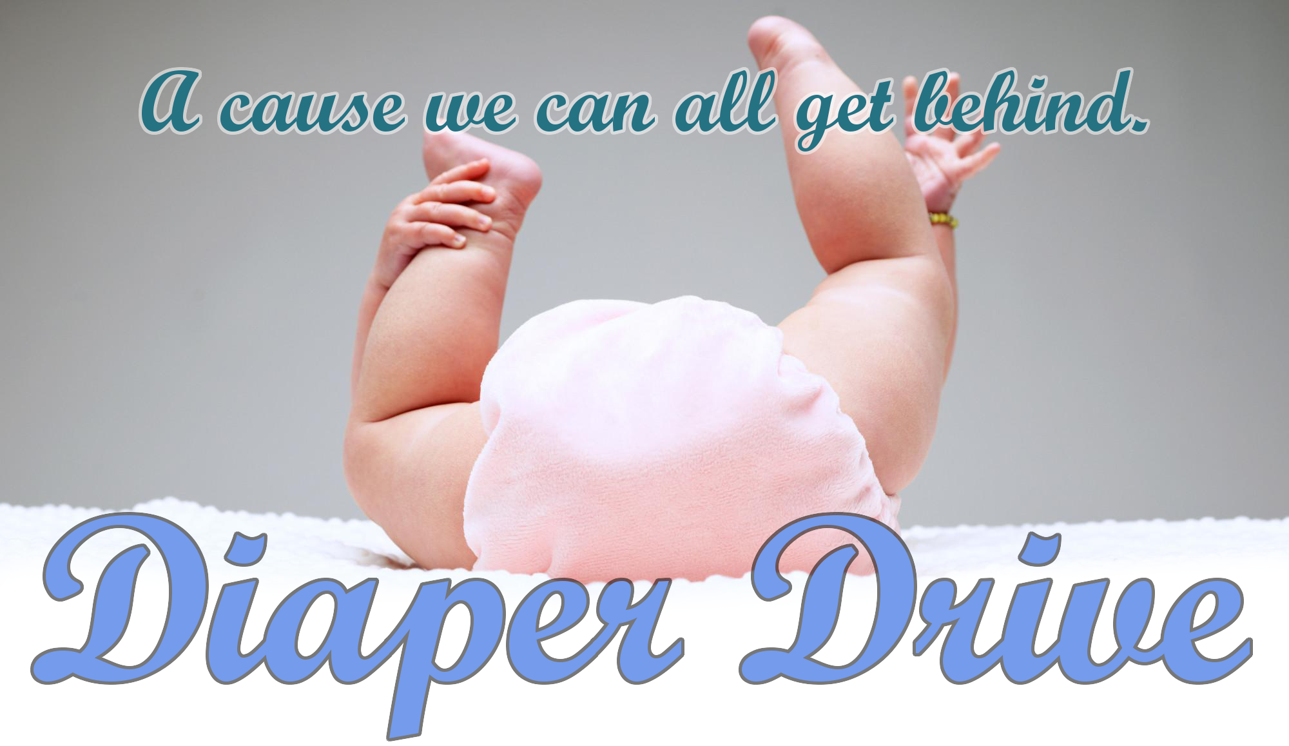

Did you know that 1 in 3 American families don’t have enough diapers to keep their babies (and toddlers) clean, dry, and healthy? That is a staggering number of families. With the support of our community, we’re making the commitment to help.

